**Question 4**

Implement a new GUI class App that combines user-defined tkinter widget classes Calculator and Mortgage displayed below: (This question can be done using a .py file)

Output

Calculator

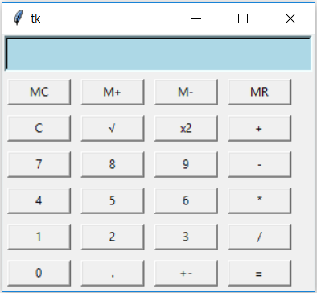

Mortgage

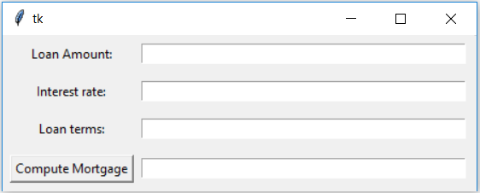

GUI (Combined)

